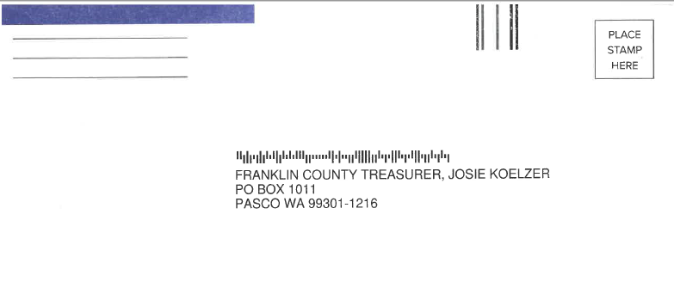
NEW ENVELOPES
Franklin County Treasurer’s office will have new return enveloped for tax payers in 2022. Due to supply chain disruption our vendor was unable to get the usual blue envelopes we mail out every year. Therefore, you will receive the envelop you see in the attachment. It will be a white envelope with a blue bar on the top left corner. Should you have any questions please call us at 509-545-3818 or email at Treaurer@franklincountywa.gov

